**Theorical explanation:**

# Accesibility of the web:

* 1.1.1 Non-text Content (meeted):
  + Technique H37: used to give a text alternative to the images, used in all the images of the web.
  + Technique Aria6: used to give a text alternative to the buttoms, for example, in the navigation menu.
* 1.4.1 Use of color (meted and advisored):
  + Technique C15: Is applied in the navigation var, when hovering the appearance is enhanced.
  + Technique G182: Is applied in the navigation menu, it is explained later in Accesibility improvements.

# Accesibility improvements:

* When hovering in the navigation var only color was used to enhance, and applying the technique G182 I made an styla enhancement in addition of the previous

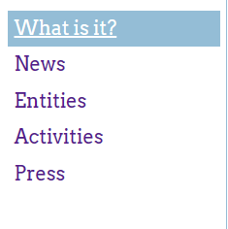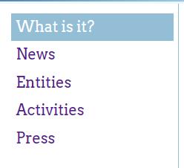Before:

After:

* Color ratios are improved as shown:

Before:

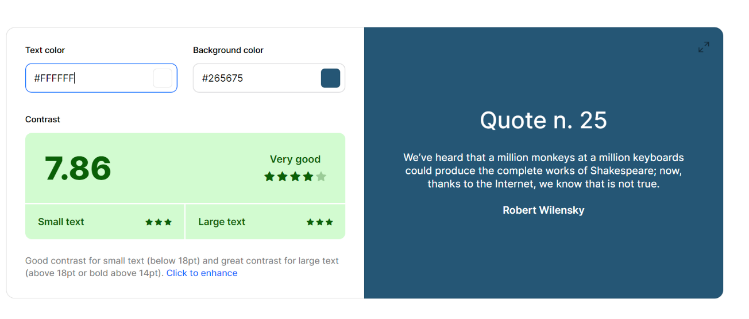After:

This change has given me more problems with the contrast that I have solved:

Before:



After:



* Another change I performed is at the header because the colour ratio was so low, I have had doubts about this change because I wasn’t able to evaluate if the contrast between the text and the background was acceptable despite the black shadow, but just in case I changed it:

Before:

After:

# Validation of the documents:

For the validation of the documents I have used the following page: [ValidatorOfHtml](https://www.cssportal.com/html-validator/) and [ValidatorOfCss](https://www.cssportal.com/css-validator/).

In both Html I receive a warning concerning the Header because it recommends me to use h1 to h6 header, but I’ve used the headers according to the nested level in the code, so I decided to keep this change to keep the accessibility.

Here are the results of the validation:

* index.html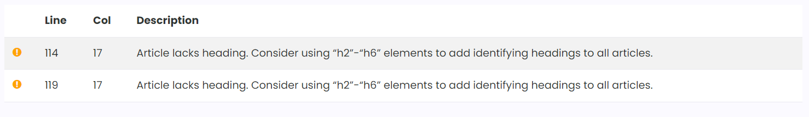
* news.html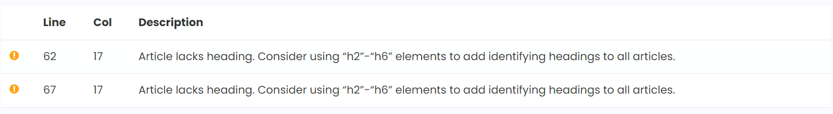
* style.css

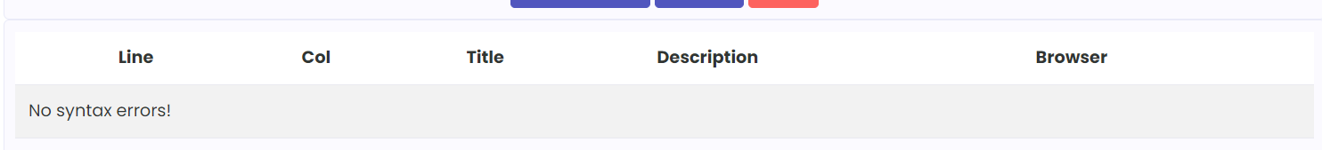

# Explanation of the entities used:

## HTML:

* Head: includes all the configuration of the document, including the fonts used in the css.
* Header: Here is the first part of the page when the page is presented.
  + H1: this is the unique use of h1 providing a brief resume of the page.
* Ul: used in multiple places, in the side menu, and in all the articles because it provides an easy way to order the information, and gives me the flexibility to show all the data as wanted.
* Main: is used to organize the middle part of the page, using this I can use flexible functions to order the others selectors
* Article: is used to order the sections of the information in div
* Blockquote: used to show the releases, this allows to add the author and is used to write quotes.
* Cite: show the authors name.
* Figure: use to store the images required in the fourth article allows to store images
* Img: is the tag used to show the images
* Alt: provides an accessibility option to text readers instead of the images.
* Footer: is the last part of the page.

## CSS:

* Display:flex: allows to organice in a flexible way the blocks inside.
* Flex-direction: order the block in horizontal.
* Justify-content: flex-start: order the blocks at the same level in a horizontal way of the main container
* Padding: sets the padding of the box, same left right etc
* Margin: sets the margin of the box, same left right etc
* Background-colour: sets the colour of the background
* Border: allows to create a line with a style and a color in the border of the box.
* List-style-type: set the icons that marks the elements of a list.
* Text-decoration: allow you to add decoration to the text for example underline.
* Color: sets the colour of the text
* Background-image: sets an image as background of the box
* Background-size: sets how the image respond to the box
* Background-position: sets where the image starts.
* Background-repeat: sets if the image is shown multiple times to fulfil the box
* Font-family: sets the font of the text.